Investigation of pitch fault on the response of spar-type floating wind turbine

Simulation task

Extreme Cases considered:

DLC 7.1a (pitch mechanism fault)

EWM turbulent wind, extreme sea state conditions. Pitch seized at three azimuthal positions. Idling and standstill case.

Select four characteristic environmental state based on the 1-yr contour line of North sea

V1,1-hour=k1*V1,10-min

σ1,1-hour=σ1,10-min+b

The significant wave height for 1-hr simulation

k2=1.09

the global extreme environmental action has a combined recurrence period of 1 year. In the absence of information defining the long term joint probability distribution of extreme wind and waves, it shall be assumed that the extreme 10-min wind speed with 1-year recurrence period occurs during the extreme sea state with 1-year recurrence period.

Waves

ESS: Hs=k2*Hs1



Yaw misalignment: 0, 10, 20,( -10, -20)

Blade 1 Pitch angle: 0, 90

Blade2 pitch angle 0, 90

Blade3 pitch angle 0, 90

Standstill azimuth angle of blade1: 0, -30, -60

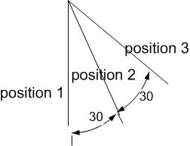

Long-crested wave direction: +90, +45, 0, -45, -90

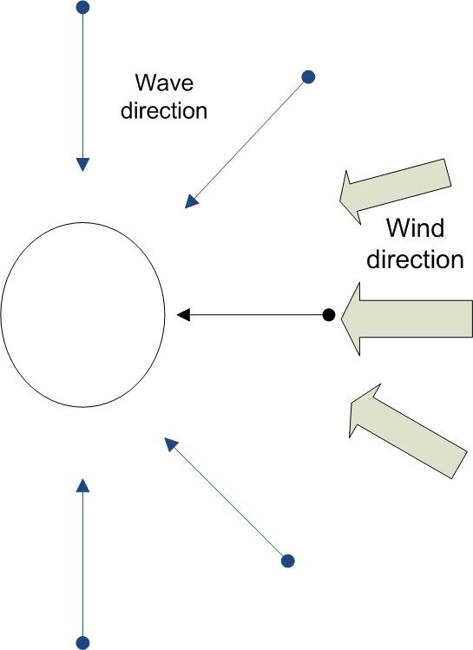

Design cases:

Method1 use of Uw based on 1-yr recurrence value



Uw,1yr=30.655 m/s (10 m above water line), E(Hs|Uw)=12.23 m, E(Tp|Uw)=14.44 s

Hs=k2*12.23=13.33 m, extrapolated to the hub height, with power factor=0.14, we get

1. hour mean speed U=41.70 m/s why use 10 min wind speed, sigma=0.1.
2. hour long simulation is run, the seed num for each 15 min wind and wave sim. Is different.

Sea state 1 Cases:

1 wavedir=0, winddir=0, Standstill-feathered case of U=38.7m/s, I=0.12, Hs=12.0, Tp=14.2 s. p1,p2,p3

Compare the sensitivity to the responses to the azimuth angle

2 wavedir=0, winddir=0, Standstill-blade2seized case of U=38.7m/s, I=0.12, Hs=12.0, Tp=14.2 s. p1,p2,p3

Compare the sensitivity to to the azimuth angle: blade bending moment, nacelle surge, tower bottom bending moment, nacelle acc., tower bottom shear force, pitch angle, yaw angle, roll angle, damping

Compare the extreme values and response spectrum, find the most critical azimuth position

3 wavedir=0, winddir=0, Standstill-feathered case of U=0m/s, I=0.12, Hs=12.0, Tp=14.2 s. pcritical, see if some responses are larger due to lower aerydynamic damp.

4 wavedir=0, winddir=0,Standstill-blade2seized case of U=0m/s, I=0.12, Hs=12.0, Tp=14.2 s. pcritical

5 wavedir=90, winddir=0, Standstill-feathered case of U=38.7m/s, I=0.12, Hs=12.0, Tp=14.2 s. p_critical

6 wavedir=90, winddir=0, Standstill-blade2seized case of U=38.7m/s, I=0.12, Hs=12.0, Tp=14.2 s. p_critical

7 wavedir=45, winddir=0, Standstill-feathered case of U=38.7m/s, I=0.12, Hs=12.0, Tp=14.2 s. p_critical

8 wavedir=45, winddir=0, Standstill-blade2seized case of U=38.7m/s, I=0.12, Hs=12.0, Tp=14.2 s. p_critical

Repeat the process for sea state2,3